Financial Excellence

The Power To Prosper

Defeating The Salary Slave Syndrome

|  |  |  |  |  |  |
| --- | --- | --- | --- | --- | --- |
| HOME | THE PROGRAM | REGISTER | CONTACT | STORE | FACEBOOK |

HOME

The majority of Canadians are living from pay-check to pay-check! The main reason for this dilemma is ‘a TRIPLE “S” mind-set’ i.e. The Salary Salve Syndrome.

Money is a TOOL, a TRIAL and a TEST.

To expose a person’s true character, give them access to large sums of money. Money reveals the heart and the quality of character.

HOWEVER, money is a necessity - it is necessary for life and required for living.

Money explains everything:

* The POOR want it.
* The RICH horde it.
* It controls those who cannot control it.
* It destroys those who love it.
* The average man works for it.
* The Wise man makes it work for him.

All human beings have a unique set of principles they live by and that is why money means different things to different people. Money takes on what ever significance you give it. Taking the time to identify your values will help you understand what is actually important about money to you. Because you are a creature of emotion, what you do is an extension what is important to you – the heart of every matter is the heart of the matter – *For out of the abundance of his heart, his mouth speaks: King Solomon.*

Not two persons are exactly alike. Neither are the principles they choose to live by. But all live from the heart. This is precisely why you must take time to understand what is most important to you about money.

Wealth isn’t about money only. Wealth is a GIFT – you should safeguard it; nurture it; and share it productively. Everyone and each family has its own beliefs and unique circumstances relating to wealth management.

What is the ‘Salary Slave Syndrome’?

Slaves to wages!

The gist of this phenomena is that an individual (or both spouses) get to a point in their life where if they did not receive the income that they currently are getting - they will end up in bankruptcy!

**TRUTH:**

As soon as INCOME = EXPENDITURE, the individual (or family) is headed for bankruptcy! They are ONE crisis away from disaster.

**RESULT:**

At this point, FEAR RULES & all other options are blinded.

They are stuck in a job where they will put up with all kinds of situations – possible abusive bosses; working late hours without additional pay; taking on extra work loads aimed at pleasing the boss/employer (hoping they will be looked on favourably if a slow down occurs). Etc.

However, there some people – despite their financial condition – tend to keep their jobs for a number of reasons e.g. job-title (Vice-President); the job defines them (Auditor) etc. These are really sociopaths (i.e. psychologically challenged).

**DEBT:** The primary reason that they cannot ‘leave’ their job is due to the heavy debt burden that they carry. This could be to numerous reasons: some not due their own faults and others primarily due to their own desires.

Acts of Nature: Sickness to parents (borrowing to meet specific needs – medications etc.); House damage not covered by insurance. Etc.

Self Imposed Debt: Greed – instant gratification (buying on installment); student loan debt (getting a degree in underground water bubbling & cannot find a job); buying a house (90% financed); buying a car (95% financed); Credit cards etc.

**SOLUTION:**

TRAIN2BWEALTHY has put together a program called FINANCIAL EXCELLENCE seminars to assist individuals/families to get out of the Salary Salve Syndrome by:

* Creating additional Cash Flow AND
* Building Long-Term Wealth

For details CLICK on THE PROGRAM tab

|  |  |  |  |  |  |
| --- | --- | --- | --- | --- | --- |
| HOME | THE PROGRAM | REGISTER | CONTACT | STORE | FACEBOOK |

The FINANCIAL EXCELLENCE seminars

Q. Why the need for Financial Seminars?

A. See below

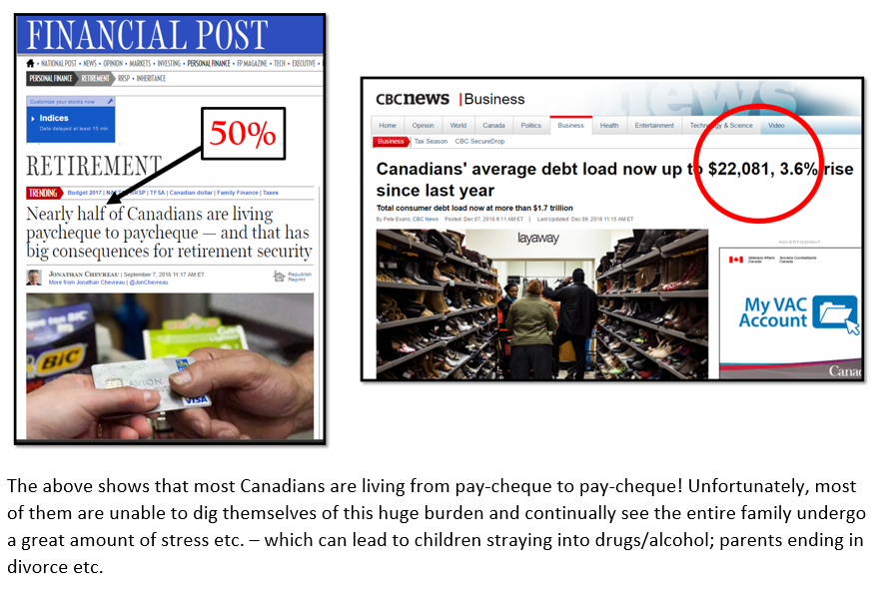

The above shows that most Canadians are living from pay-cheque to pay-cheque! Unfortunately, most of them are unable to dig themselves of this huge burden and continually see the entire family undergo a great amount of stress etc. – which can lead to children straying into drugs/alcohol; parents ending in divorce etc.

**FUNDAMENTAL TRUTH:**

Every member of a family MUST have a solid work ethic.

“Diligent hands will rule, but laziness ends in forced labor.” (Proverbs 12:24)

**Work Hard or Work Smart?**

The are numerous financial seminars – what’s different about this?

The majority of such seminars put a ‘BURDEN’ on the individual or family. What we call these seminars the “Nickel & Dime” strategy.

Basically, there is an attempt at ‘Behavior Modification’ i.e. you are to CUT costs to a bare minimum that at the end of the day, you are to make such sacrifices that it would appear that your lifestyle will just be one step above the homeless!

Example:

*How To Live The Good Life On A Shoestring Budget*

*I have learned that you can live a healthy and posh lifestyle on a shoestring budget. You just need to be smart with the resources you have. A little humility goes a long way, too.*

***Below are my top 9 tips to live well on a shoestring budget:***

***1. Find a financial plan that works for you and stick to it.***

*I've followed Dave Ramsey's financial budgeting plan for the past 15 years actually. It's a 7-Step Plan that helps you save, budget, eliminate all debt and create a financial life that equates to financial stability regardless of your salary. It's clear, simple, and the steps are followed in order, it allows you to live well on any budget.*

***2. Negotiate at the farmer's market.***

*You can eat organic produce and other healthy foods on a shoestring budget! Promise! If you're near any farmer's markets, stroll in toward the end of the day when they're packing up. Tell them you have a small budget, but it's important to you that you nourish your body with organic greens and fruits. And then ask them if they'd be willing to sell any of what's left over at a negotiated rate. It's worked for me.*

***3. Learn how to eat well on a budget.***

*Another resource I found to be helpful was Eco-Vegan Gal. In a series of short, internet videos, she explains how to eat easy, cheap and healthy vegan meals. I followed her tips and have found that I now eat better on a budget (less than $250/month) that I did when I had an unlimited budget. Other resources I like include Balanced Babe, articles that I found along the way like this one*[*,*](http://www.huffingtonpost.com/l-susan-zhang/5-ways-to-eat-healthy-on-a-budget_b_4855317.html,)*and simply having conversations with plant-based food bloggers to brainstorm how to eat on a budget.*

***4. Find ways to exercise and relax in nature.***

*Do you live near hiking trails or a beach? Grab your loved ones and spend a day hiking or lying on the sand reading a great book. If you want to have a romantic evening with your special someone, purchase an inexpensive bottle of wine. Grab a blanket and go sit at your favorite park to sip and chat. If you have a bike, you can cycle for miles to explore new neighborhoods.*

***5. Join meetup groups!***

*They often host free events where you can mingle and have a blast! You can go to MeetUp.com and browse any activity that you like! I also did a very simple google search of "Free Events in Chicago" and turned up a treasure trove of fun things like group picnics in the park, 5K runs without a sign-up fee and amazing book clubs. You can still enjoy your surroundings without spending a penny!*

***6. Let your friends know about your new financial limits.***

*If you can afford to go to restaurants, order an appetizer or split an entree with a friend who you've already informed of your budget. It's a lot cheaper than getting your own meal. When you travel, stay with friends instead of shelling out for a hotel room.*

***7. Shop at thrift stores or high-end clothing swaps.***

*You can look the part without paying for it! Shop at outlet stores or consignment shops. Another tip: wait until the end of each season, when the sales are out of this world! Learn to live with a few quality basics in your wardrobe that you can transition from day to night with a simple accessory or even makeup change.*

***8. Focus on accessorizing rather than buying new outfits.***

*You'd be amazed what a brightly-hued scarf can do for a basic t-shirt and skirt.*

***9. Work hard.***

*I have humbled myself in ways that have shocked even me. And you know what? It feels really good. If your budget is not providing the lifestyle you want, consider projects for people in your community. You can tell them that you have a small budget and would love some extra "shoe money." Offer to babysit, dog walk, organize closets, clean their home, etc. And lastly, if this is option is available to you, try to get a better-paying job.*

*There are countless ways to live a healthy and amazing lifestyle on a small budget! Give them a try and what you might find is that your life is much richer then when you had an abundance of money.* [REALLY?]

READ THE ABOVE CAREFULLY & YOU MIGHT AS WELL LIVE WITH THE VINOS IN A ROOMING HOUSE! **THIS JUST DOES NOT WORK!**

It’s not about ‘BEHAVIOR MODIFICATION’.

It’s a about a “MIND-SET” that creates what we call ‘STINKING THINKING”!

What causes people to become “wage slaves”?

TRADITION!

<https://www.youtube.com/watch?v=kDtabTufxao>

EXTERNAL

* Culture
* Tradition
* Social Background
* Education
* Ethnic group

Creates a

“BELIEF SYSTEM”

Your BELIEFS impact your THOUGHTS

Your THOUGHTS become your REALITY

Your REALITY defines your RISK PROFILE

Your RISK PROFILE

determines your RISK TOLERANCE

Your RISK TOLERANCE results in your ACTIONS

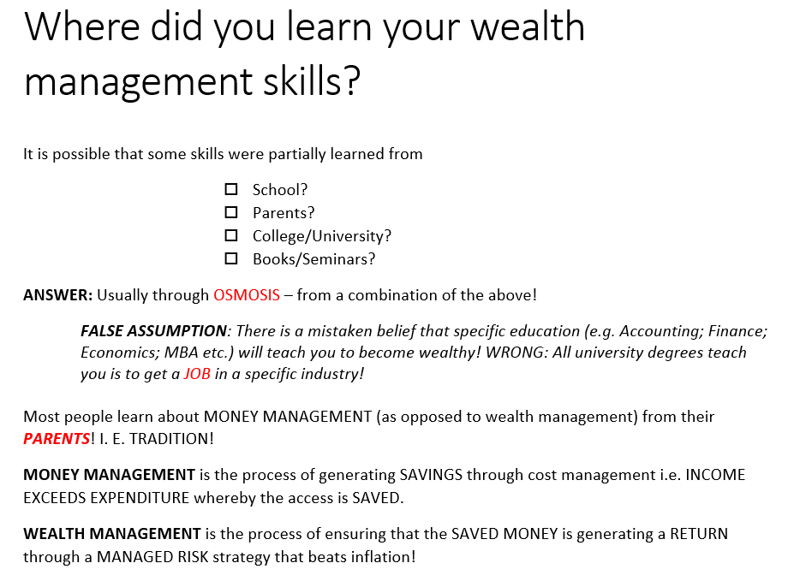

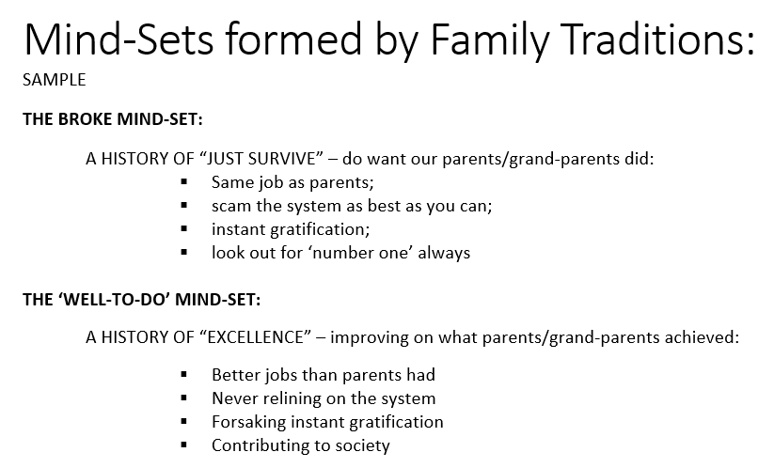

Why are some people wealthy?

1. Were they born into a wealthy family (silver spoon)?
2. Were they super intelligent (Einstein)?
3. Were they just plain lucky (649 winner)?
4. Were they selling drugs (Hell Angels member)?

While its true that some have become wealthy by some of the above reasons BUT these represent a very small portion of the wealthy. The majority of those who become wealthy have some special things going for them.

The wealthy have been TRAINED to

1. Have a **DISCIPLINED MIND** – they excel in EDUCATIONAL pursuits i.e. most have higher degrees
2. Have a **SOLID WORK ETHIC** – they sacrifice instant gratification for future benefits i.e. they treat life like a business.
3. Have a **MIND-SET** that focuses on building wealth – they have a game plan of saving and investing i.e. ensuring that their money works for them

Thomas J Stanley who wrote about the “MILLIONAIRE’s MIND” makes the following statement:

*“Based on in-depth interviews with numerous MILLIONAIRES, the study found that the following factors were vital to their financial successes:*

* *INTERGRITY – honesty in all relationships*
* *DISCIPLINE – self-control in every area of your life*
* *SOCIAL SKILLS – friendly relationship will people*
* *HARD WORK – a willingness to work harder than most people*
* *SPOUSE – a supportive spouse “*

NOTE: The FIRST FOUR are dependent on you i.e. you have some control over them BUT you may not have control over the fifth – the spouse!

THIS SEMINAR WILL TEACH YOU 2 THINGS:

1. TO THINK LIKE THE WEALTHY!
2. PROVIDES “BUSINESS OPPORTUNITIES” WITH DO NOT REQUIRE:
3. Huge CAPITAL infusion and/or
4. Massive TIME consumption

REGISTER TODAY

For details CLICK on REGISTER tab

|  |  |  |  |  |  |
| --- | --- | --- | --- | --- | --- |
| HOME | THE PROGRAM | REGISTER | CONTACT | STORE | FACEBOOK |

I am interested in attending a seminar

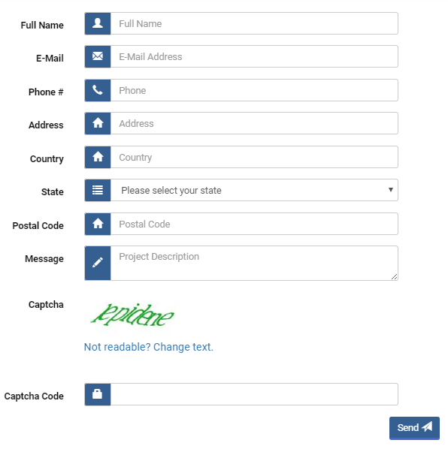

|  |  |  |  |  |  |
| --- | --- | --- | --- | --- | --- |
| HOME | THE PROGRAM | REGISTER | CONTACT | STORE | FACEBOOK |

<https://www.facebook.com/financialexcellence2017/>

|  |  |  |  |  |  |
| --- | --- | --- | --- | --- | --- |
| HOME | THE PROGRAM | REGISTER | CONTACT | STORE | FACEBOOK |

